**How to create a push GITHUB**

Step-1:

1. Create a new folder name push.

Step-2:

1. Open the folder and copy the folder name and paste it on command prompt.
2. Open the new repository and copy the first three lines code.

Step-3:

1. Open the command prompt and enter cd and give some space and paste it on new folder url.
2. Again you paste new repository three lines code.

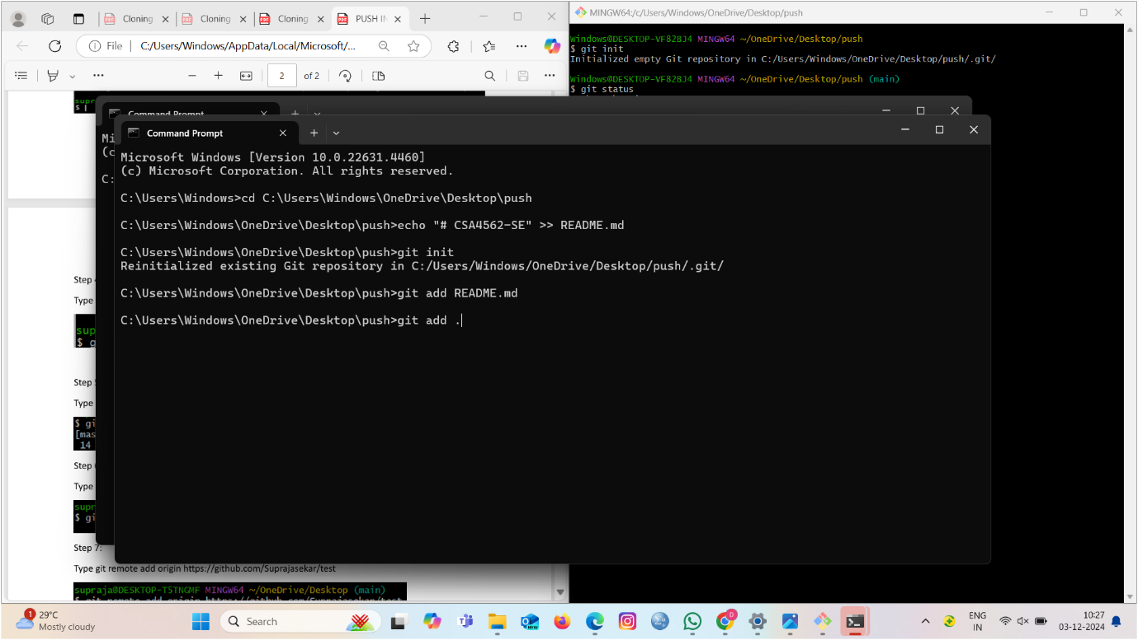

Step-4:

1. Now you give git add . again you paste another four lines code.

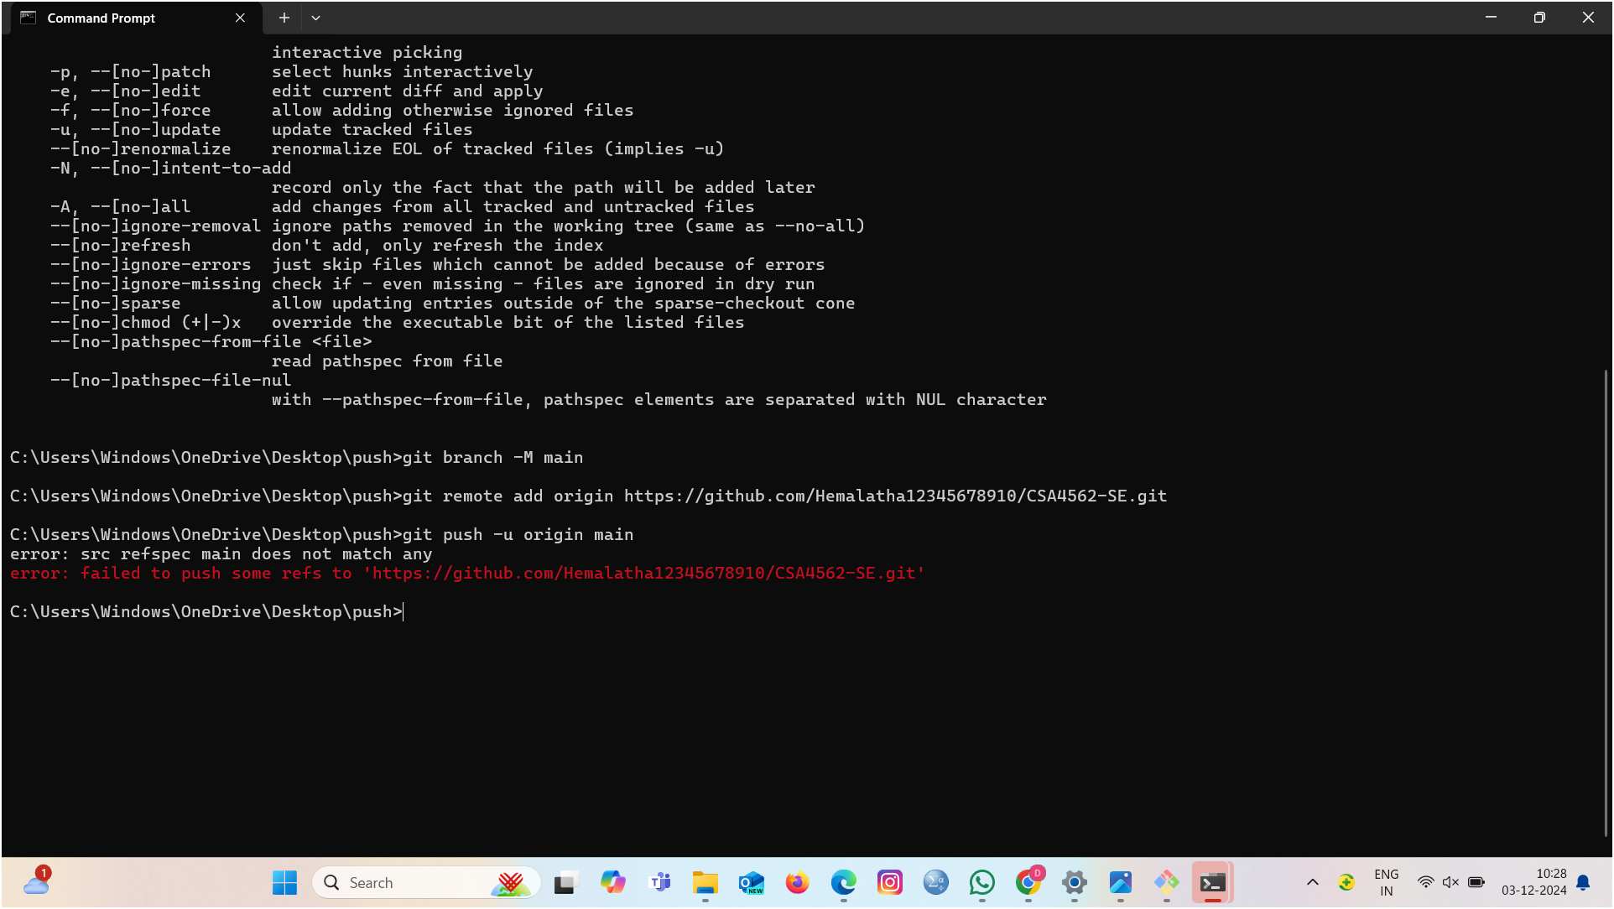

Step-5:

Check the files push.